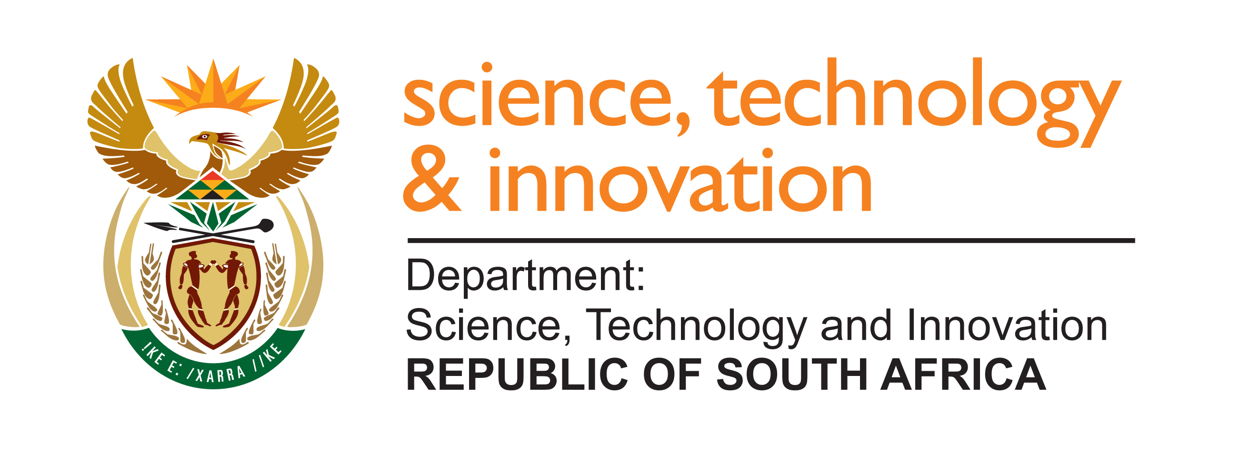

SECTOR INNOVATION FUNDS

CALL FOR PROPOSALS: ESTABLISHMENT AND MANAGEMENT OF SECTOR INNOVATION FUNDS

Successful modern economies are increasingly being characterised by strong partnerships between government, research institutions and agencies, and the private sector. Furthermore, the need to enable increased investment in, and funding for, research, development and innovation (RDI) is well established.

The Department of Science, Technology and Innovation (DSTI) established the Sector Innovation Fund (SIF) programme in 2013 and has successfully now implemented three phases of the programme. to incentivise increased private sector investment into RDI. The SIF instrument has enabled effective partnerships between government (through DSTI) and the private sector and has supported co-investment in RDI in key strategic sectors of the economy.

SIF is a flexible funding instrument that is also intended to broadly improve the economic competitiveness of a particular sector through RDI interventions. It aims to create an enabling environment for RDI priorities to be driven by industry, in a co-funding arrangement with government, thus increasing private sector investment in RDI. It is also anticipated that identified priorities in a sector could be used to stimulate other sectors or create new economic growth areas.

Following the success of the previous three phases, the DSTI is inviting proposals for a fourth phase of the SIF, as part of a continued broader government effort to support industry competitiveness. A call for proposals is therefore hereby issued to industry associations that may be interested in being part of the SIF programme.

CALL FOR PROPOSALS

Applications for funding support will be considered from industry associations or bodies, with i) legal standing. ii) a formal tax clearance certificate issued from SARS, and iii) that represent the interests of a particular industrial sector or sub-sector.

It remains a key principle of SIF that the industry association or body determines the needs for the RDI interventions required to enhance the specific sector’s competitiveness. Applications for funding should be for industry-led initiatives to build and enhance economic competitiveness broadly, including transformation, diversification and enabling employment opportunities. The research outcomes should have sector-or industry-wide benefits, and not just for individual companies or entities.

Programmes or projects that address the following are encouraged and will be prioritized: (i) technologies and innovations that support the competitiveness, local value added and modernisation of priority industrial sectors in the short to medium-term, (ii) resource efficiency, the circular economy or zero-waste economy, (iii) a more inclusive and gender balanced economy and (iv) strengthening the growth of SMEs and new entrants, as well as a focus on encouraging participation from new stakeholders including increased number of women.

The key objectives of SIF will remain the following:

1. Increasing the general level of sector RDI in South Africa
2. Improving the general competitiveness of supported sectors
3. Increasing the RDI capacity in supported sectors
4. Increasing the level of private sector investment in RDI
5. Transformation (which includes opportunities for emerging players, as well as the need to transform the researcher base)

FUNDING STATUS AND PFMA DISCLAIMER

- All applicants responding to this Call for Proposals do so entirely at their own financial, legal and operational risk. The DSTI does not accept any liability or obligation whatsoever for any costs, losses, or commitments incurred by applicants in the conceptualization, preparation or submission of proposals.
- Any prospective evaluation or shortlisting of a proposal does not constitute a commitment to fund. Funding for any SIF programme under this initiative is strictly conditional upon the availability of appropriated funds allocated to the Department. In accordance with the Public Finance Management Act (PFMA), Act 1 of 1999, the Department cannot incur any financial commitments exceeding its approved budgetary votes. Funding is therefore explicitly subject to:
  - The formal allocation and release of funds by National or Provincial Treasury for this specific phase of the SIF initiative; or
  - The availability of virement or authorized internal reallocation of departmental funds under Section 43 of the PFMA
- While proposals for multi-year RDI programmes are encouraged, the DSTI does not guarantee multi-year funding at this stage. Contracts will strictly comply with Treasury Regulations and will run according to government financial years (1 April to 31 March), contingent upon annual budget approvals.
- The DSTI retains the absolute right to cancel, reduce, or amend the scope of this initiative at any stage based on shifting fiscal frameworks.

QUALIFYING CRITERIA

The SIF funding may be used for the following:
- Government-private sector co-funded RDI activities;
- Feasibility or pilot studies to determine the key RDI needs of the specific sector or sub-sector;
- Start-up phases of RDI projects, including capacitation of key stakeholders and beneficiaries;
- Facilitating the transfer, demonstration, and testing of promising technologies and solutions to end-users;
- High-end skills development and research capacity building (including support for post-graduate students);
- Project management (subject to the conditions set out below) and monitoring and evaluation costs.

A vital performance measure of the programme will remain to increase the level of private sector funding into RDI that is conducted in South Africa. This will be measured by the amount of (new) funding an industry sector contributes to the identified RDI programmes to match government (DSI) funding.

It must be noted that the following types of applications will not be considered for support:
- RDI programmes that are exclusively aimed at human capital development (there should be a minimum of 30%, and a maximum of 50%, spent on support for students and interns
- Applications that include projects that are for business or market intelligence

NON-QUALIFYING COSTS

The following is a list of costs that do NOT qualify under this call:
1. Passenger vehicles (i.e. non-commercial vehicles)
2. People Carrier Minibuses, even if registered in the applicant (entity’s) name
3. Rates and taxes
4. Training that is not related to the RDI programme of the SIF
5. Software and accounting packages
6. Furniture and office equipment
7. Costs incurred before submission of proposal

The DSTI reserves the right to determine the eligibility of a cost based on the objectives of the SIF programme.

MINIMUM CONDITIONS TO BE MET BY APPLICANTS

- Legal status of applicant
Applications for funding support will be considered from industry associations or bodies, with i) legal standing and ii) a formal tax clearance certificate issued from SARS, and iii) that represent the interests of a particular industrial sector or sub-sector.

- Programme management fee limits

Programme management costs are limited as follows:
a) For contracts in which the DST&I investment is less or equal to R10m: 10%
b) For contracts in which the DST&I investment is above R10m: 7%

- Minimum co-funding contribution
The SIF’s main objective is to incentivise increased private sector investment into RDI in key strategic sectors of the economy. A vital performance measure for SIF is the amount of matching funding an industry sector contributes to the identified RDI programme to match government (DST&I) funding. During Phase-04 of SIF, there will be a strict 1:1 matching funding cash contribution from the private sector industry partners. It is advisable that this commitment is secured before an application is submitted at the earliest, and at the latest, before the first draft of the contract is finalised (if the application is successful). ALL RDI projects, including those that are aimed at meeting transformation imperatives, as well as programme management fees, will have to include an industry co-funding contribution.

Please note that successful applicants will be required to provide evidence of the industry contributions at least annually, as per the DST&I’s prescribed template. The industry co-funding contributions may also be the subject of an audit.

Depending on the quality and quantum of proposals received, the DST&I may follow a sliding scale approach to this co-funding requirement, which may include an initial DST&I “heavy” upfront investment. Should this become necessary, please note that it is anticipated that contracts will still be concluded for three to four years, and the industry matching funding will be a contract obligation.

- HCD Transformation requirements
Research programmes must meet the following conditions:
  - Research teams must be composed of 30% Black South Africans (African, Coloured and Indian)
  - 80% of students and interns supported must be Black South Africans (African, Coloured, and Indian)
  - 50% of students and interns supported must be female
  - Programmes should have a minimum of 30% and maximum of 50% spend on support for students and interns.

- Progress reports
All reporting will be as per the DST&I prescribed template and format, on a quarterly and annual basis
Industry associations will be required to account for expenditure of DSTI funding separately to industry funding
The DSTI reserves the right to conduct a pre-contracting audit to assess whether the financial systems of the proposed fund managers are adequate for financial management and reporting purposes.

6. Governance and calls for proposals

Applicants should note that a specific SIF related governance structure will need to be established, consisting of a i) technical review committee, and a ii) steering committee. In addition, successful applicants will be required to issue calls for proposals for new RDI projects relevant to the industry identified needs.

7. Reporting timelines

The reporting timeline will be in line with DSTI’s financial year, i.e., the twelve month
period starting from 1 April to 31 March.

Please note that reports will be due promptly at the end of every quarter and year, as appropriate.

- VAT Considerations
It should be noted that the proposal submitted must be inclusive of VAT. The DSTI contract will be VAT inclusive, and all budgets must therefore take this into account. Income and expenditure must be accounted for accordingly. Industry co-funding contributions must also be calculated on a VAT inclusive basis.

GENERAL COMMENTS

Preference will be given to applications that will develop a RDI project portfolio that has a healthy mix of early-stage R&D projects with later stage projects that are closer to implementation, and which have deliberate actions aimed at addressing the transformation imperative of South Africa.

It is important to note that the performance in the earlier phases of SIF will be a consideration in the evaluation of proposals from sectors/applicants that have been supported in previous phases of the programme.

